实验5 JPA
一．实验目的
理解JPA实体、Entity Manager的作用，掌握实体、Entity Manager类的使用方法；理解JPA实体映射的作用，掌握其访问方法。
二. 实验环境
硬件：PC系列微机，CPU1.2G以上，内存512M以上
软件：Windows 11； edge浏览器、JDK1.8、Eclipse Version: Oxygen.3a Release (4.7.3a)、Tomcat8.0.26、MySQL8.0等。
三. 实验内容
1、根据现实中的学生对象编写实体类Student。
2、使用Entity Manager实现对Student的增删改查。
3、根据现实中的班级和班长，编写单向一对一映射。
4、根据现实中的学校和学院，编写单向一对多映射。
四. 实验过程
1、根据现实中的学生对象编写实体类Student。
package model;

import java.io.Serializable;
import javax.persistence.*;
import java.util.Date;
import java.util.List;
/**
* The persistent class for the student database table.
*
*/
@Entity
@NamedQuery(name="Student.findAll", query="SELECT s FROM Student s")
public class Student implements Serializable {
private static final long serialVersionUID = 1L;

@Id
private String stuid;

private int age;

@Temporal(TemporalType.DATE)
private Date birthday;

private String name;

private String sex;

//bi-directional many-to-one association to Classinfo
@ManyToOne
@JoinColumn(name="className")
private Classinfo classinfo;

//bi-directional many-to-many association to Course
@ManyToMany
@JoinTable(
name="sc"
, joinColumns={
@JoinColumn(name="stuid")
}
, inverseJoinColumns={
@JoinColumn(name="cno")
}
)
private List<Course> courses;
public Student() {
}
public Student(String stuid, String name) {
super();
this.stuid = stuid;
this.name = name;
}
public String getStuid() {
return this.stuid;
}
public void setStuid(String stuid) {
this.stuid = stuid;
}
public int getAge() {
return this.age;
}
public void setAge(int age) {
this.age = age;
}
public Date getBirthday() {
return this.birthday;
}
public void setBirthday(Date birthday) {
this.birthday = birthday;
}
public String getName() {
return this.name;
}
public void setName(String name) {
this.name = name;
}
public String getSex() {
return this.sex;
}
public void setSex(String sex) {
this.sex = sex;
}
public Classinfo getClassinfo() {
return this.classinfo;
}
public void setClassinfo(Classinfo classinfo) {
this.classinfo = classinfo;
}
public List<Course> getCourses() {
return this.courses;
}
public void setCourses(List<Course> courses) {
this.courses = courses;
}
@Override
public String toString() {
return "Student [stuid=" + stuid + ", name=" + name + "]";
}
}
- 使用EntityManager实现对Student的增删改查。
测试方法：
@Test
public void test(){
// this.addStudent1();

// Student updatedstudent=this.getSingleStudent("201707101192");
// updatedstudent.setName("孙帅康");
// this.updateStudent(updatedstudent);
// this.delStudent("1");

List<Student> students=this.getStudents();
for (Student student: students) {
System.out.println(student);
}}
- 增
public void addStudent1() {
EntityManager em=EntityManagerUtil.getEntityManager();
Student student = new Student();
student.setName("ssk");
student.setStuid("1");
student.setSex("男");
em.getTransaction().begin();
em.persist(student);
em.getTransaction().commit();

em.close();
}
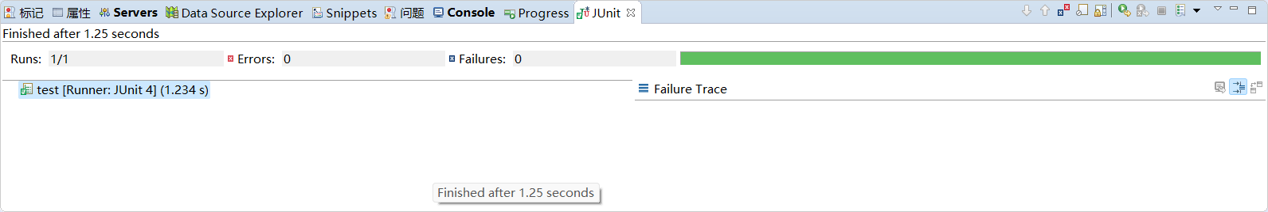
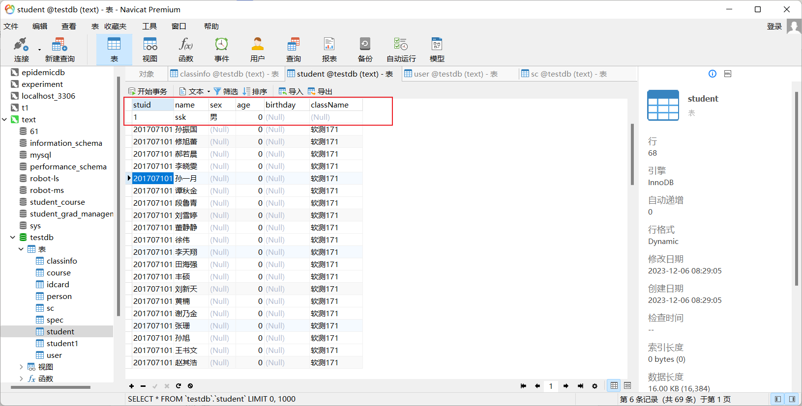
- 删
public void delStudent(String stuid){
EntityManager em=EntityManagerUtil.getEntityManager();
Student student=em.find(Student.class, stuid);
em.getTransaction().begin();
em.remove(student);
em.getTransaction().commit();
em.close();
}
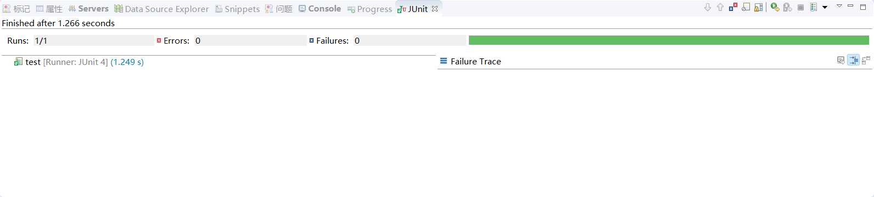
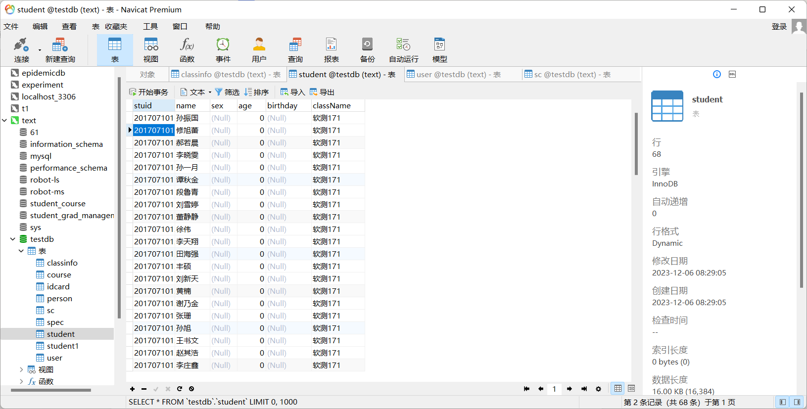
- 改
public void updateStudent(Student student){
EntityManager em=EntityManagerUtil.getEntityManager();
em.getTransaction().begin();
em.merge(student);
em.getTransaction().commit();
em.close();
}
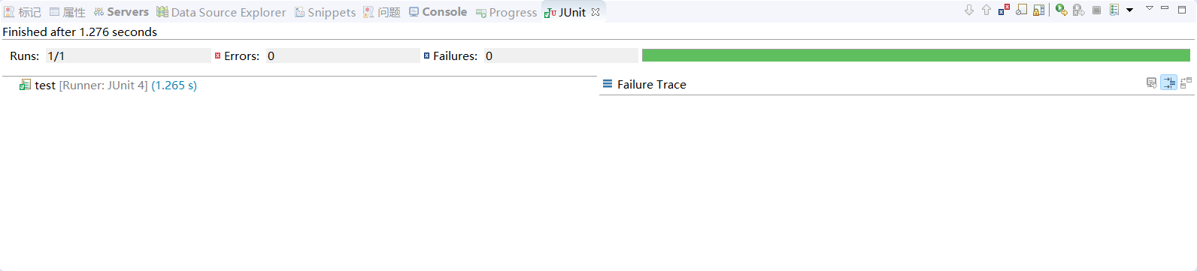
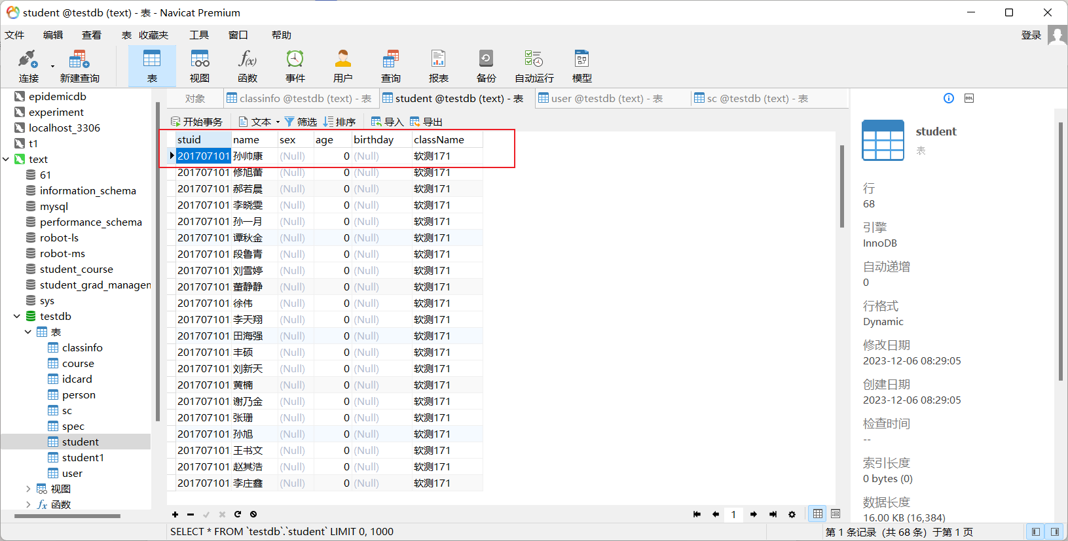
- 查
/**查询单个学生信息*/
public Student getSingleStudent(String stuid) {
EntityManager em=EntityManagerUtil.getEntityManager();
Student student=em.find(Student.class, stuid);
em.close();
return student;
}
public List<Student> getStudents(){
EntityManager em=EntityManagerUtil.getEntityManager();
Query query=em.createNamedQuery("Student.findAll");
List<Student> students=query.getResultList();
em.close();
return students;
}
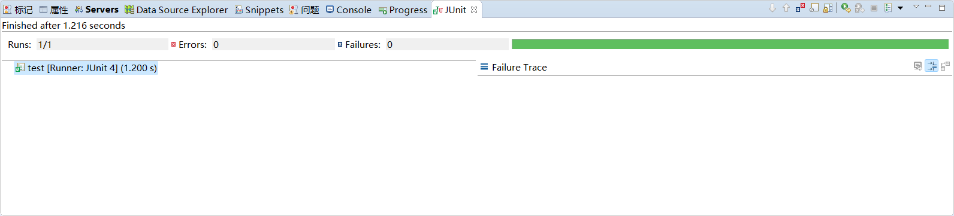
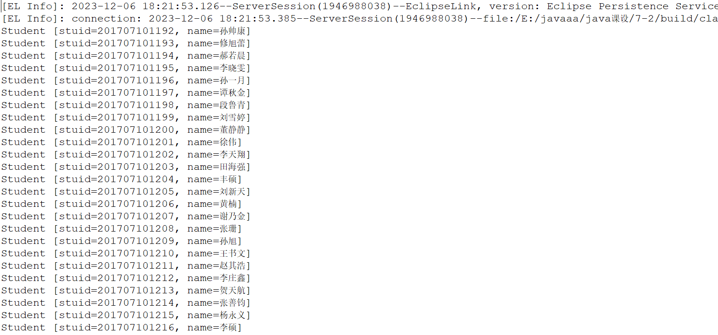
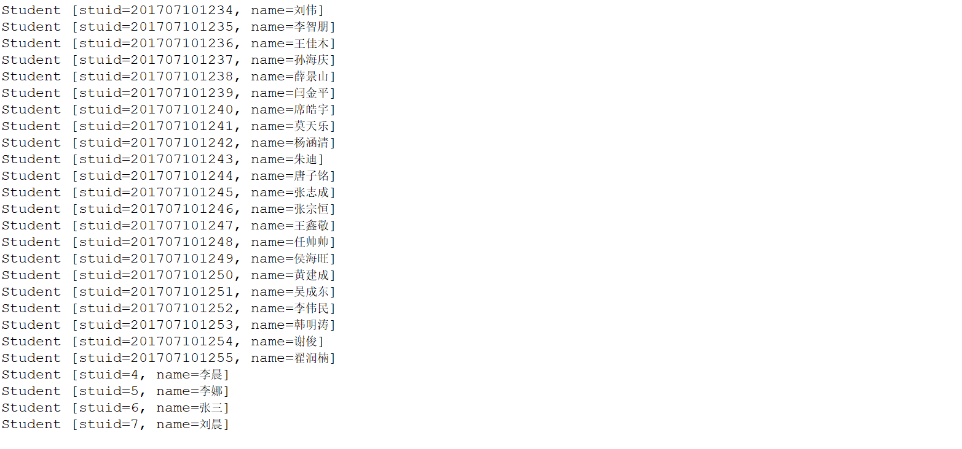
- 根据现实中的班级和班长，编写单向一对一映射。
班级实体：
package model;

import java.io.Serializable;
import javax.persistence.*;
import java.util.List;
/**
* The persistent class for the classinfo database table.
*
*/
@Entity
@NamedQuery(name="Classinfo.findAll", query="SELECT c FROM Classinfo c")
public class Classinfo implements Serializable {
private static final long serialVersionUID = 1L;

@Id
private String className;

private String tutor;

//bi-directional many-to-one association to Spec
@ManyToOne
@JoinColumn(name="specid")
private Spec spec;

//bi-directional many-to-one association to Student
@OneToMany(mappedBy="classinfo")
private List<Student> students;

//bi-directional one-to-one association to Idcard
@OneToOne
@JoinColumn(name="Monitor_id")
private Monitor monitor;

public Classinfo() {
}

public String getClassName() {
return this.className;
}

public void setClassName(String className) {
this.className = className;
}

public String getTutor() {
return this.tutor;
}

public void setTutor(String tutor) {
this.tutor = tutor;
}

public Spec getSpec() {
return this.spec;
}

public void setSpec(Spec spec) {
this.spec = spec;
}

public List<Student> getStudents() {
return this.students;
}

public void setStudents(List<Student> students) {
this.students = students;
}

public Student addStudent(Student student) {
this.getStudents().add(student);
student.setClassinfo(this);

return student;
}

public Student removeStudent(Student student) {
this.getStudents().remove(student);
student.setClassinfo(null);

return student;
}

@Override
public String toString() {
return "Classinfo [className=" + className + ", tutor=" + tutor + ", spec=" + spec + ", students=" + students
+ "]";
}}
班长实体
package model;

import java.io.Serializable;
import javax.persistence.*;
/**
* The persistent class for the idcard database table.
*
*/
@Entity
@NamedQuery(name="Monitor.findAll", query="SELECT m FROM Monitor m")
public class Monitor implements Serializable {
private static final long serialVersionUID = 1L;

@Id
private int Monitor_id;

private String MonitorName;

//bi-directional one-to-one association to Person
@OneToOne(mappedBy="monitor")
private Classinfo classinfo;

public Monitor() {
}

public int getMonitor_id() {
return Monitor_id;
}

public void setMonitor_id(int monitor_id) {
Monitor_id = monitor_id;
}

public String getMonitorName() {
return MonitorName;
}

public void setMonitorName(String monitorName) {
MonitorName = monitorName;
}

public Classinfo getClassinfo() {
return classinfo;
}

public void setClassinfo(Classinfo classinfo) {
this.classinfo = classinfo;
}}
- 根据现实中的学校和学院，编写单向一对多映射。
学校实体
package model;

import java.io.Serializable;
import javax.persistence.*;
import java.util.List;

/**
* The persistent class for the classinfo database table.
*
*/
@Entity
@NamedQuery(name="School.findAll", query="SELECT sch FROM School sch")
public class School implements Serializable {
private static final long serialVersionUID = 1L;

@Id
private String schoolName;

private String rector;

//bi-directional many-to-one association to Student
@OneToMany(mappedBy="school")
private List<Spec> specs;

public School() {
}

public String getSchoolName() {
return schoolName;
}

public void setSchoolName(String schoolName) {
this.schoolName = schoolName;
}

public String getRector() {
return rector;
}

public void setRector(String rector) {
this.rector = rector;
}

public List<Spec> getSpecs() {
return specs;
}

public void setSpecs(List<Spec> specs) {
this.specs = specs;
}
}
学院实体
package model;

import java.io.Serializable;
import javax.persistence.*;
import java.util.List;
/**
* The persistent class for the spec database table.
*
*/
@Entity
@NamedQuery(name="Spec.findAll", query="SELECT s FROM Spec s")
public class Spec implements Serializable {
private static final long serialVersionUID = 1L;
@Id
private String specid;

private String specmag;

private String specname;

//bi-directional many-to-one association to Classinfo
@OneToMany(mappedBy="spec")
private List<Classinfo> classinfos;

//bi-directional many-to-one association to Classinfo
@ManyToOne
@JoinColumn(name="schoolName")
private School school;

public Spec() {
}

public String getSpecid() {
return this.specid;
}

public void setSpecid(String specid) {
this.specid = specid;
}

public String getSpecmag() {
return this.specmag;
}

public void setSpecmag(String specmag) {
this.specmag = specmag;
}

public String getSpecname() {
return this.specname;
}

public void setSpecname(String specname) {
this.specname = specname;
}

public List<Classinfo> getClassinfos() {
return this.classinfos;
}

public void setClassinfos(List<Classinfo> classinfos) {
this.classinfos = classinfos;
}

public Classinfo addClassinfo(Classinfo classinfo) {
getClassinfos().add(classinfo);
classinfo.setSpec(this);

return classinfo;
}

public Classinfo removeClassinfo(Classinfo classinfo) {
getClassinfos().remove(classinfo);
classinfo.setSpec(null);

return classinfo;
}
public School getSchool() {
return school;
}

public void setSchool(School school) {
this.school = school;
}}

- 实验总结
通过本次实验，我深入理解了JPA实体，以及Entity Manager的作用，并且掌握了实体类的编写，entity manager方法的使用，理解了单向一对一、一对多映射的代码编写及访问原理。一开始对于jpa的语句查询更新使用不熟练，后通过学习比这老师的源码，进行实现。

